AI Assisted Coding.
Assignment-6.1
Name : Omprakash.
HT No : 2303A52057.
Batch No : 39.
Task Description #1 (AI-Based Code Completion for Loops)
Task: Use an AI code completion tool to generate a loop-based
program.
Prompt:
“Generate Python code to print all even numbers between 1 and N
using a loop.”
Expected Output:
• AI-generated loop logic.
• Identification of loop type used (for or while).
• Validation with sample inputs
Prompt :
#Write Python code to take user input N and print all even numbers from 1 to N using a loop.

Code :
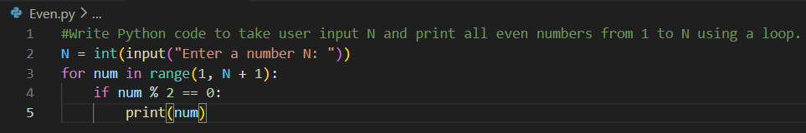
OUTPUT :
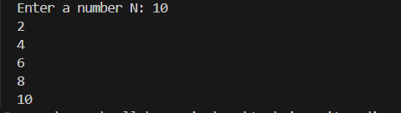

Task Description #2 (AI-Based Code Completion for Loop with
Conditionals)
Task: Use an AI code completion tool to combine loops and
conditionals.
Prompt:
“Generate Python code to count how many numbers in a list are even
and odd.”
Expected Output:
• AI-generated code using loop and if condition.
• Correct count validation.
• Explanation of logic flow

Prompt :
#Write Python code to take a list of numbers from the user and count how many are even and odd.

Code :
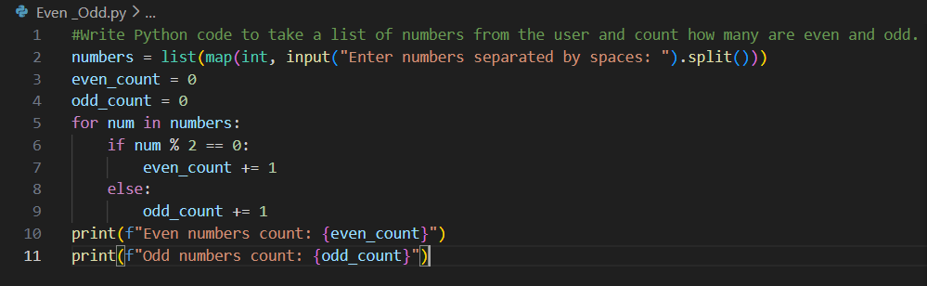
OUTPUT :
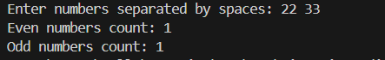

Task Description #3 (AI-Based Code Completion for Class
Attributes Validation)
Task: Use an AI tool to complete a Python class that validates user
input.
Prompt:
“Generate a Python class User that validates age and email using
conditional statements.”
Expected Output:
• AI-generated class with validation logic.
• Verification of condition handling.
• Test cases for valid and invalid inputs.
Prompt :
#Create a Python class User that takes age and email as user input and validates them using if conditions.

Code :
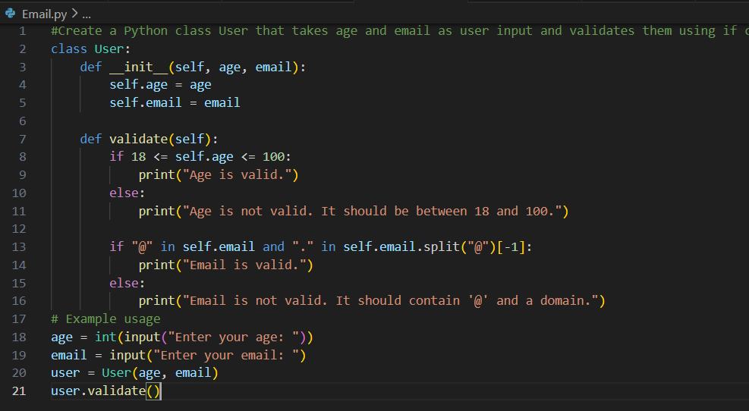
OUTPUT :
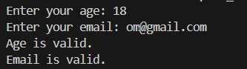
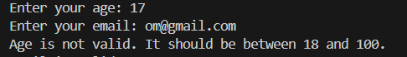

Task Description #4 (AI-Based Code Completion for Classes)
Task: Use an AI code completion tool to generate a Python class for
managing student details.
Prompt:
“Generate a Python class Student with attributes (name, roll number,
marks) and methods to calculate total and average marks.”
Expected Output:
• AI-generated class code.
• Verification of correctness and completeness of class
structure.
• Minor manual improvements (if needed) with justification.
Prompt :
#Create a Python class Student that takes name, roll number, and marks as user input and calculates total and average marks.

Code :

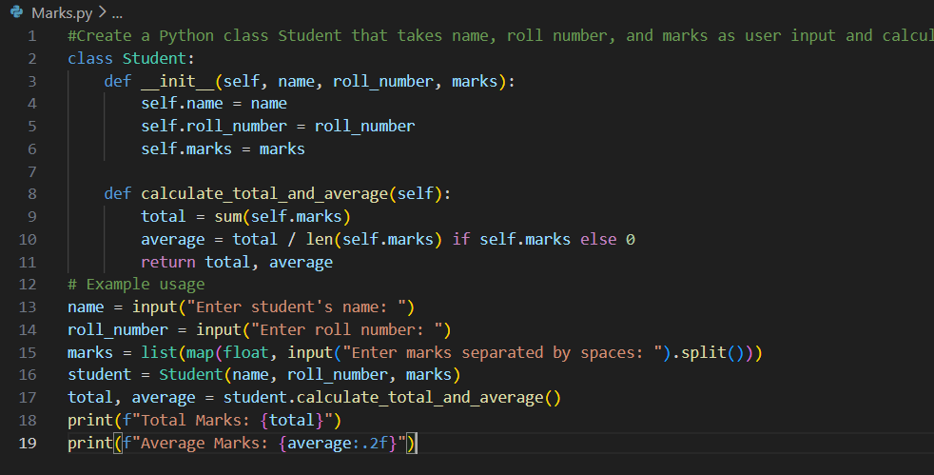
OUTPUT :
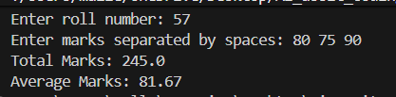

Task Description 5 (AI-Assisted Code Completion Review)
Task: Use an AI tool to generate a complete Python program using
classes, loops, and conditionals together.
Prompt:
“Generate a Python program for a simple bank account system using
class, loops, and conditional statements.”
Expected Output:
• Complete AI-generated program.
• Identification of strengths and limitations of AI suggestions.
• Reflection on how AI assisted coding productivity.

Prompt :
#Create a simple Python bank account program using class, loops, and conditions that takes user input for deposit, withdrawal, and balance check.

Code :
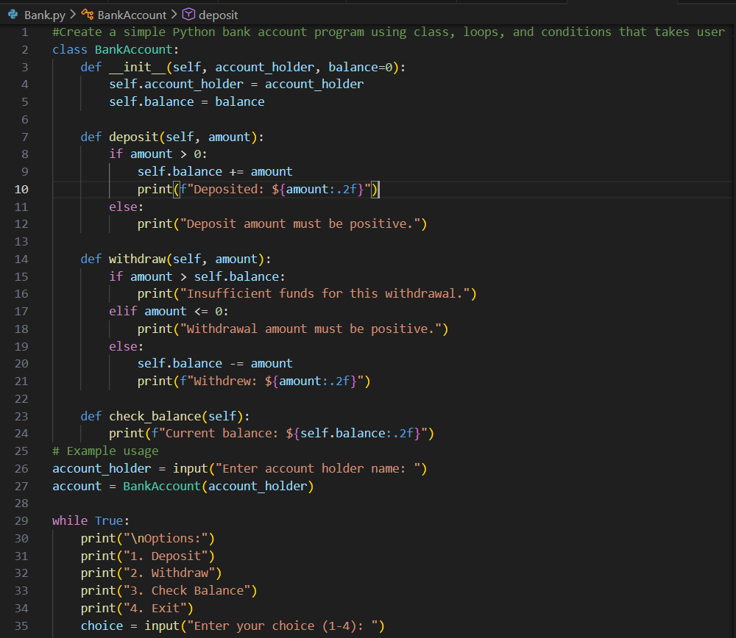
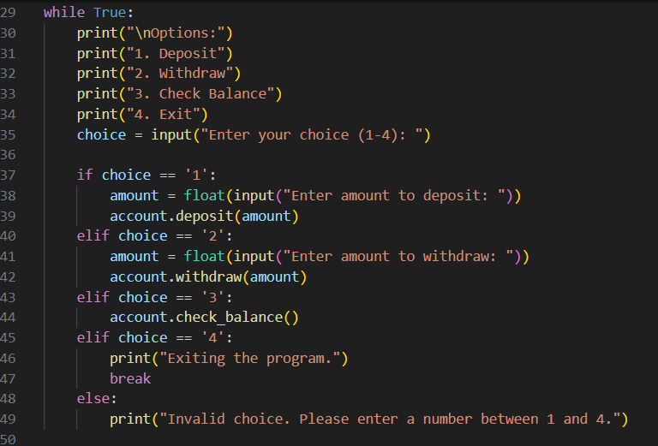

OUTPUT :
